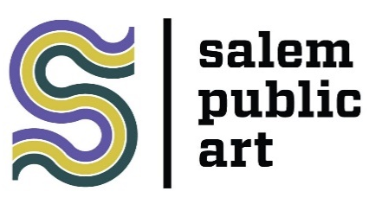
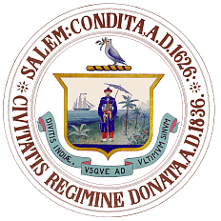
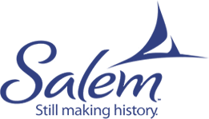

FOR IMMEDIATE RELEASE

February 28, 2022

FOR MORE INFORMATION, CONTACT:
Julie Barry, Senior Planner for Arts & Culture
City of Salem | Department of Planning & Community Development
98 Washington St., 2nd Floor | Salem, MA 01970
978-619-5685 ext. 42506 | jbarry@salem.com

2022 Salem Arts Festival Mural Slam Call for Artists
The City of Salem’s Public Art Commission and the Salem Arts Festival are teaming up to present the 7th annual Salem Arts Festival Mural Slam (SAF Mural Slam). This dynamic live painting event engages the public with creative producers and contributes to downtown Salem’s cultural vitality. Salem Arts Festival is a project of Salem Main Streets and Creative Collective.

The site for the 2022 SAF Mural Slam is Artists’ Row, a historic marketplace that has evolved into a vibrant corridor of galleries and public art at the heart of downtown, located at 24 New Derby Street. Selected SAF Mural Slam artists will have the opportunity to present their work alongside the skilled artisans of Artists’ Row and will benefit from exposure to Salem’s million+ annual tourists. (Live painting is subject to COVID regulations, in the event that we cannot present this in person, we will allow the artists to create in more distanced private and/or public locations.)

In the interest of visually enlivening this creative hub for residents and visitors alike, the City of Salem and Salem Arts Festival are inviting twelve (12) artists to showcase their talents and contribute to keeping Artists’ Row and downtown Salem a destination for world-class, inspiring and engaging public art.

Deadline for Applications: March 31, 2022 at 11:59pm
Notification of Selection: April 22, 2022
Salem Arts Festival Mural Slam: June 4 & 5, 2022
Apply Now through our easy online portal here: 2022 Application
(https://bit.ly/SAF-MURAL-SLAM-2022)

Details and Info
Who can Apply?: Anyone may apply, either solo or in small teams. Students are also encouraged to apply. Artists may come from anywhere, but preference will be given to local artists and to artists who have not participated in previous Mural Slams.

Timeframe: Saturday, June 4 & Sunday, June 5, 8:30am – 8:30pm. It is anticipated that artists will complete the mural in this timeframe. Depending on weather and time needs artists may begin work on Friday, June 3. (Live painting is subject to COVID regulations, in the event that we cannot present this in person, we will allow the artists to create in more distanced private and/or public locations.)

Stipend and Awards: Each artist will receive a $500.00 stipend for their participation. Artists will also be eligible to compete for a $500.00 prize for the People’s Choice Award. Payment of the stipend and to the winner of the award will be paid within four weeks after the Mural Slam.

Painting Surface: There twelve (12) available walls slots for the 2022 Salem Mural Slam. Each slot will be hung with a white primed ½ inch marine grade plywood sheet mounted to the existing brick walls. The format will be 8’ wide by 4’ tall. Murals must be oriented in the same horizontal configuration.

Materials/Supplies: Due to the close proximity to other artists and local businesses during the event, along with practical considerations for drying time, acrylic and latex paints with low VOX rated for outdoor use will be the only media permitted during the 2022 Salem Mural Slam. Individual painting surfaces describe above will be provided. All paints, supplemental materials, brushes, and tools must be provided by the artist.

Finished Murals: Murals will be hung on the buildings along Artists’ Row for up to a year from completion. All Murals become the property of the City of Salem and Salem Arts Festival if not claimed by the artist at the end of the year’s display.

Submission Requirements & Review Criteria:
Artists will be asked to submit:
- Brief biographical statement
- CV or Artists Resume
- 5-10 examples of past work
- A sketch or mockup of their idea for the mural slam
- A brief descriptive statement about their proposed idea for the mural slam

Artists will be evaluated on the following criteria:
- High Artistic Merit
- Originality and Composition of the Work
- Suitability for a Family-Friendly Environment
Applications will be considered ineligible if they involve:
- A breach of intellectual property rights (i.e., somebody else's ideas or imagery)
- Trademarks, brand or business names, logos or copyrighted images
- Anything that is harmful to a third party
- Anything containing nudity or overtly Halloween themed
- Submitted after the deadline noted above

The City of Salem Code of Ordinances provides that no individual should be denied equal treatment or opportunity as a result of his or her age, ancestry, color, disability, family status, gender identity or expression, military status, marital status, national origin, race, religion, sex or sexual orientation. Any activities which denies or tends to deny to an individual equal access on the basis of: age, ancestry, color, disability, family status, gender identity or expression, military status, marital status, national origin, race, religion, sex or sexual orientation, is hereby prohibited.

###

